**Question 1:** **Start Hadoop single node on AcadGild VM.**

**Answer:** The command for starting single node on AcadGild VM is start-all.sh

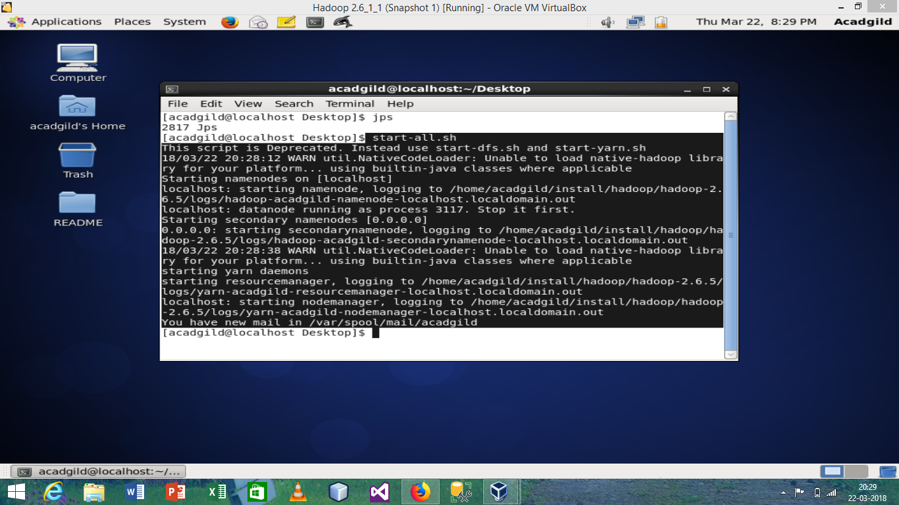

This is the screenshot for starting Hadoop single node on AcadGild VM.

**Question 2: Run a JPS command to see if all Hadoop daemons are running.**

**Answer:** After running single node Hadoop cluster, to see Hadoop daemons which are running, we use JPS command.

The same is shown in the below screenshot. Black portion showing the name of Hadoop daemons.

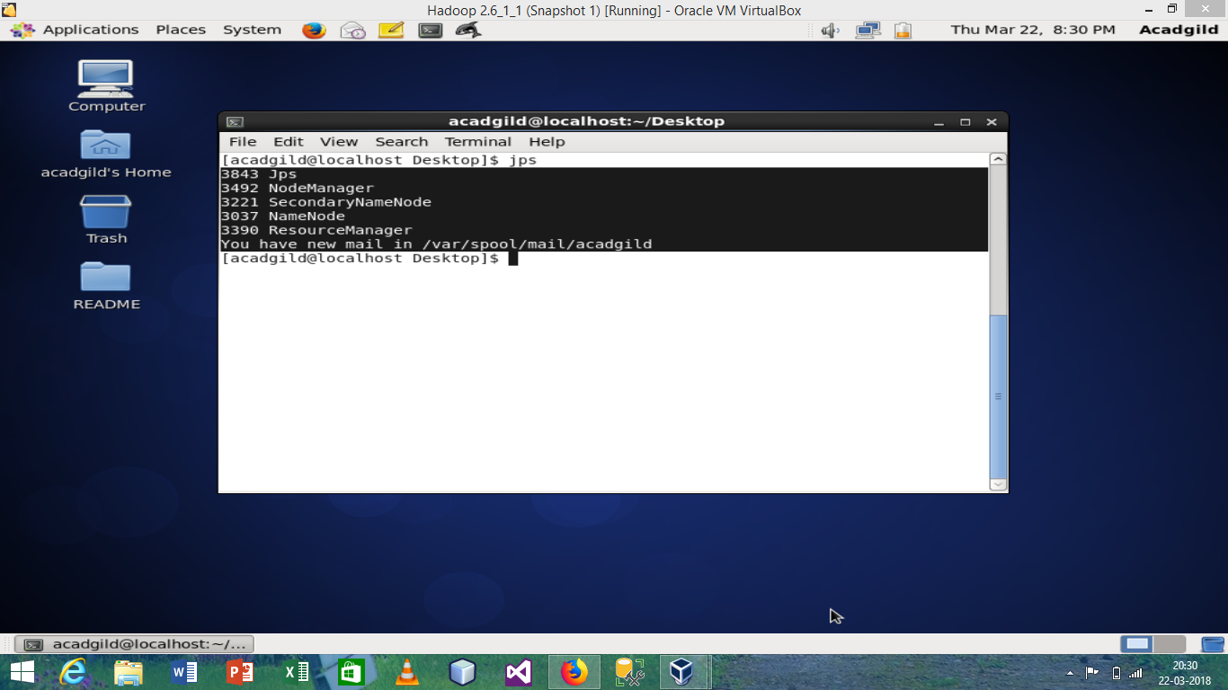

**Question 3: Run few Unix commands like pwd, ls -ls, etc.**

**Answer:**

Command 1:

pwd – present working directory (output shown in black portion)

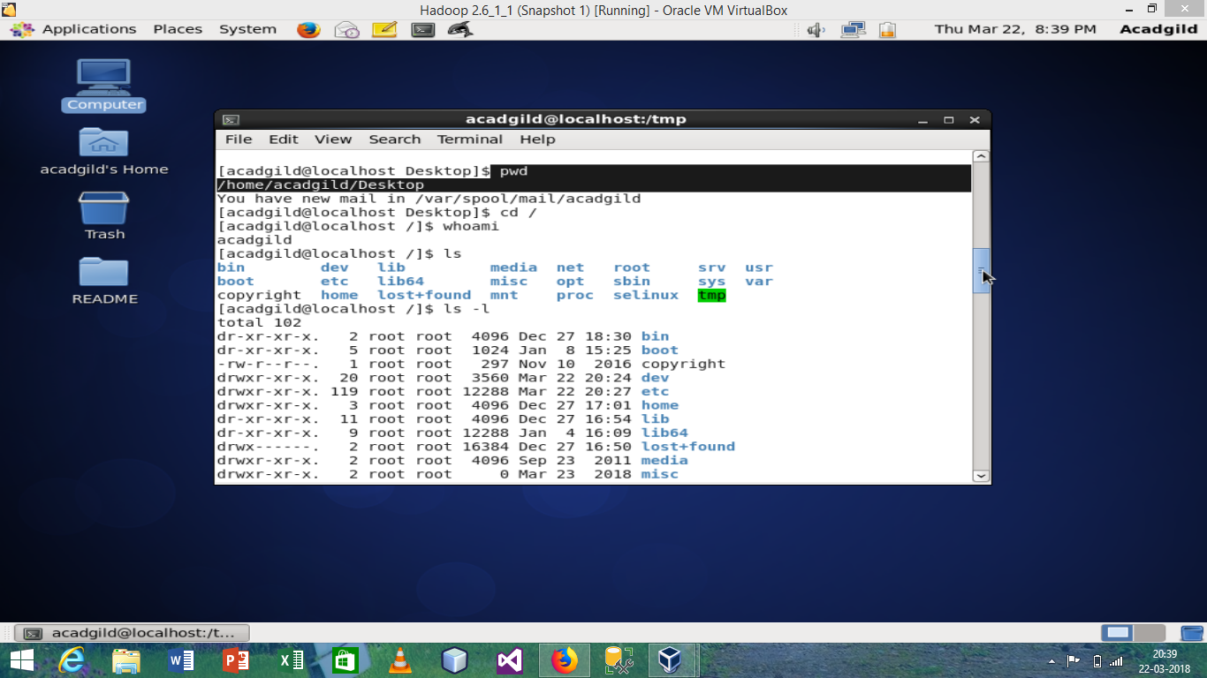

Command 2:

Cd –change directory

Example: cd / - means change the directory to /

(same as shown in black marked portion)

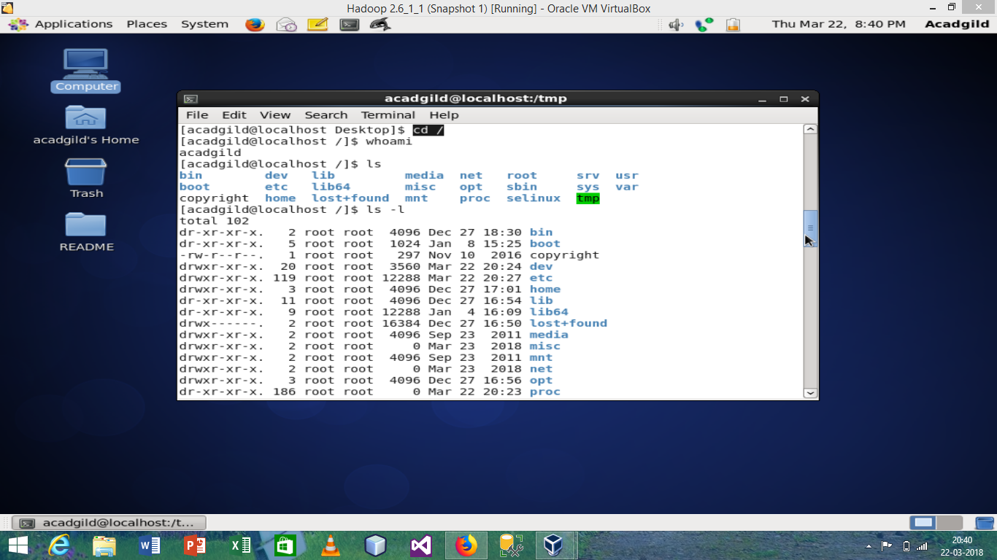

Command 3:

whoami – tell us about the current user

(Output shown in figure, the blacked portion)

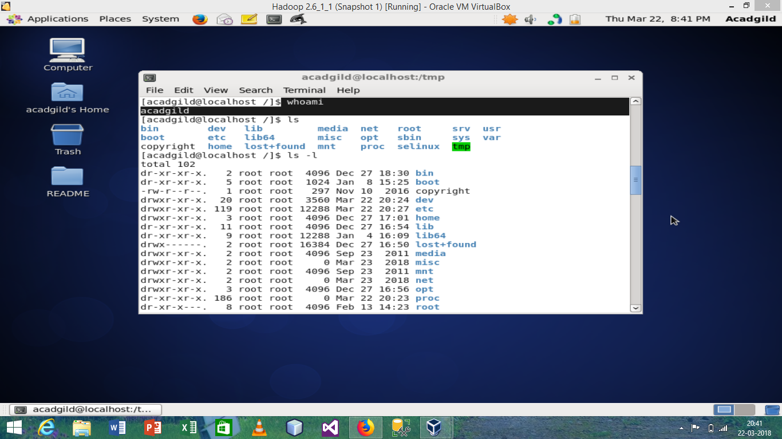

Command 4:

ls – long listing

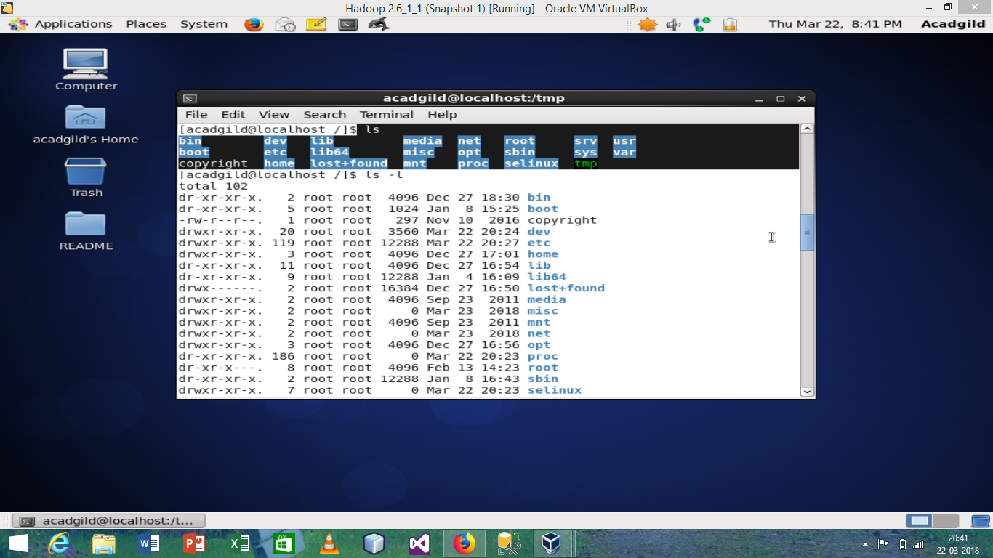

with this we can use different argument like

ls -l - means long listing with extra information

(the black portion shows the output of ls and the white portion shows the output of ls -l)

Command 5

ls -a - shows the hidden file also

(output shown in blacked portion only)

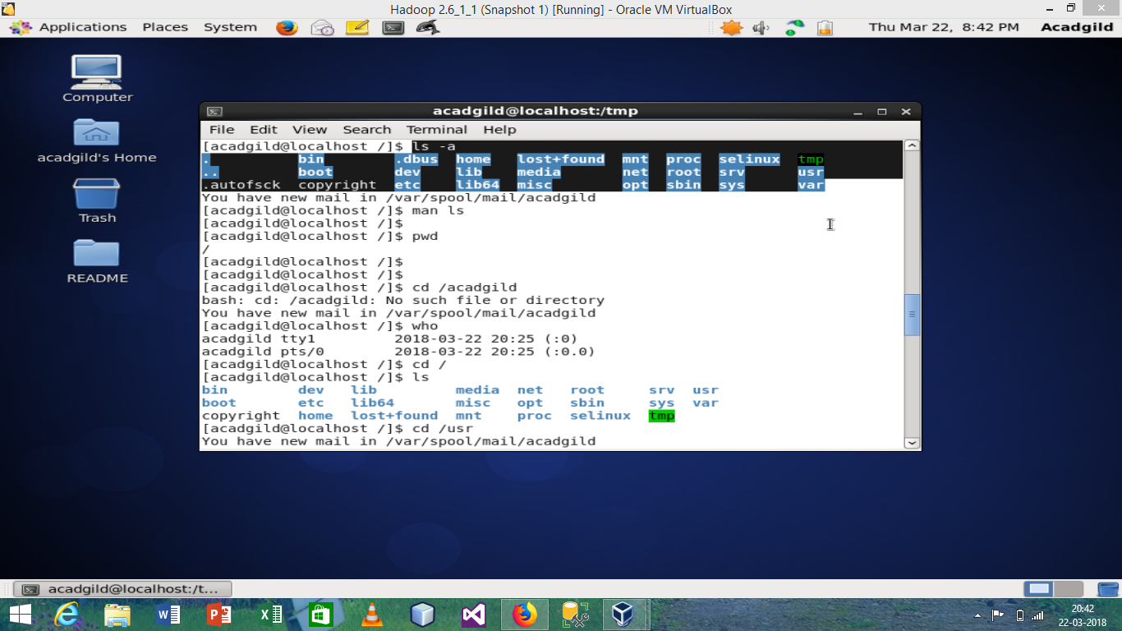

**Question 4: Create a file from the terminal using Nano editor (example: Nano test.txt), and add some content in it. Cat it to see if the content is saved**.

**Answer:** we use **nano text.text** command to create and edit text file. The same is shown in screenshot (blacked portion).

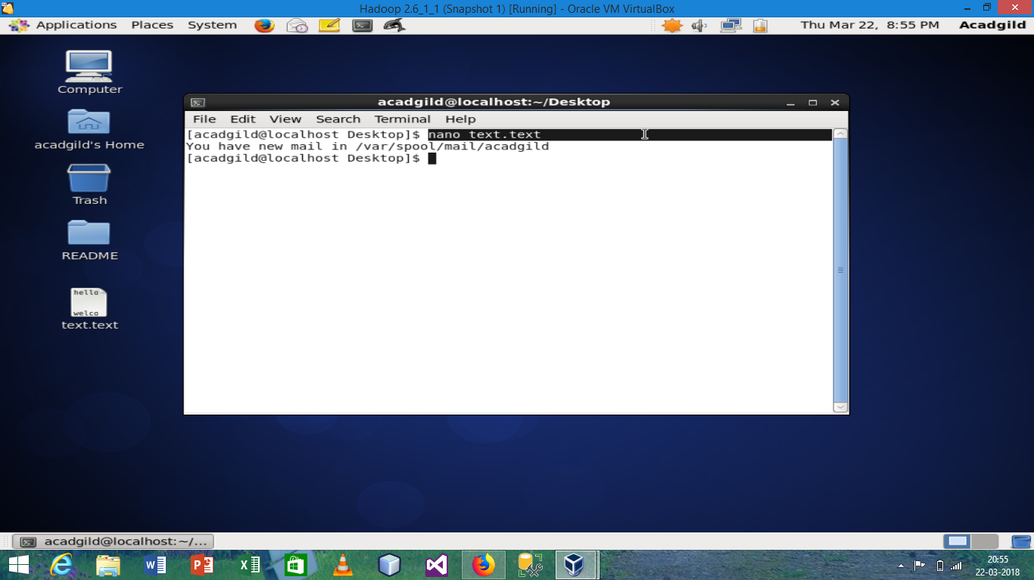

This is how the nano editor looks like

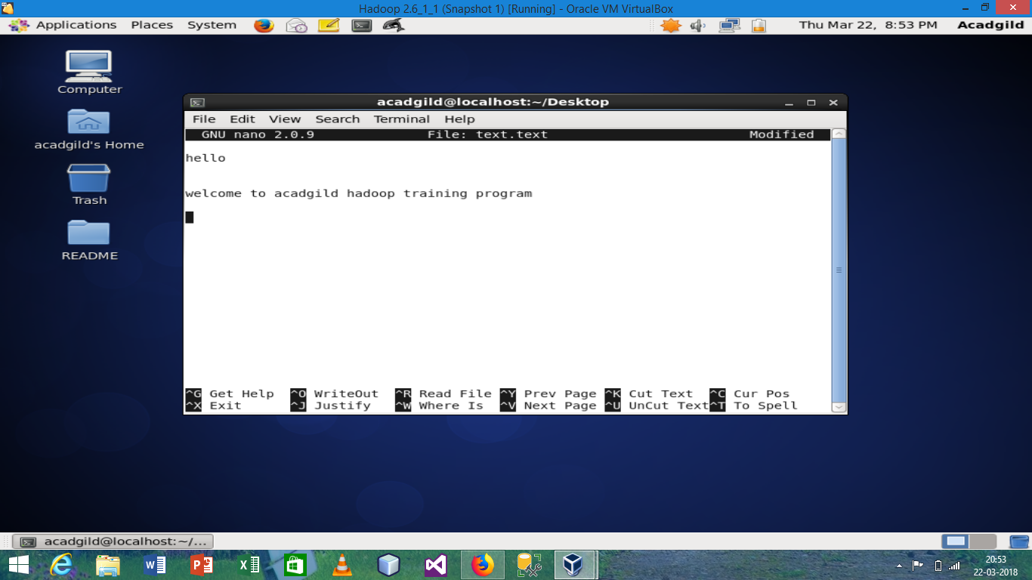

We write the data as shown in screenshot to save and exit the file we use **Ctrl+X** and then press enter.

This is how we can save the file.

Now to see the file we use command as **cat <file name>**

Example is shown in screenshot (black portion only)

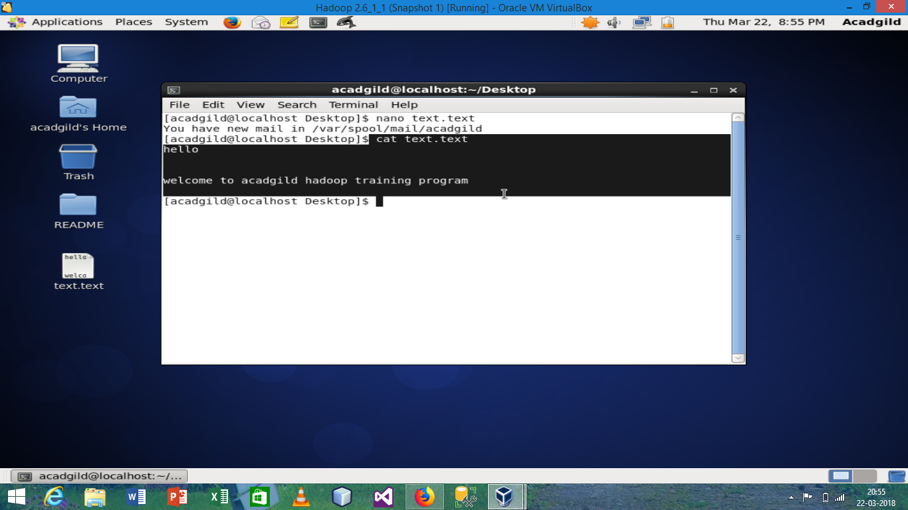

**Question 5: Open the hdfs web page by typing localhost: 50070 in the browser. Check all the details of the HDFS.**

**Answer:** Information about the version, cluster id etc. (shown in screenshot blue portion)

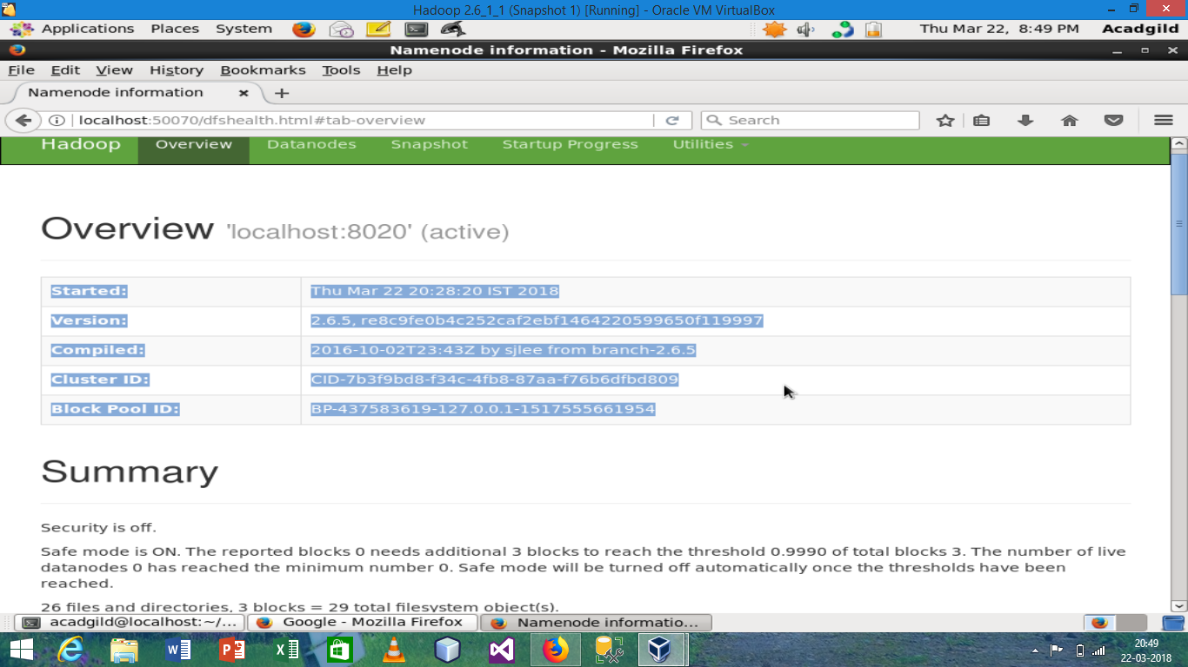

The information about the memory used means dfs used or remaining related information

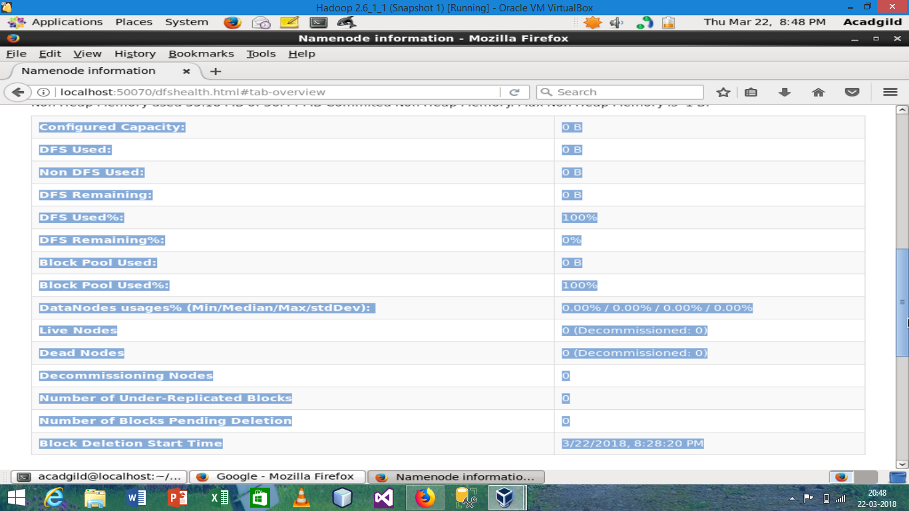

Information about Datanode.

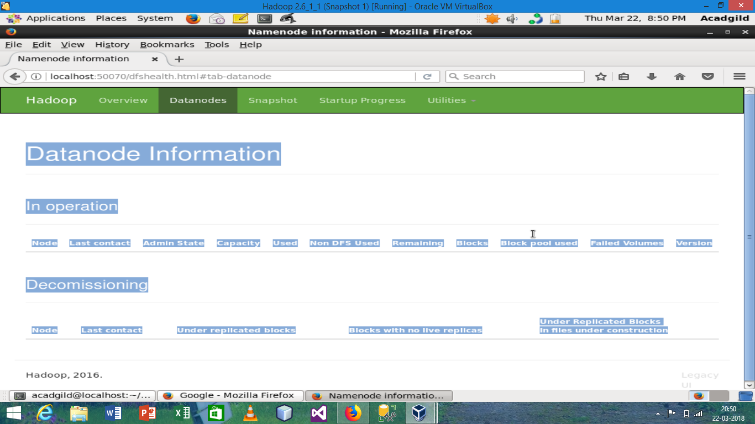

Information about snapshot

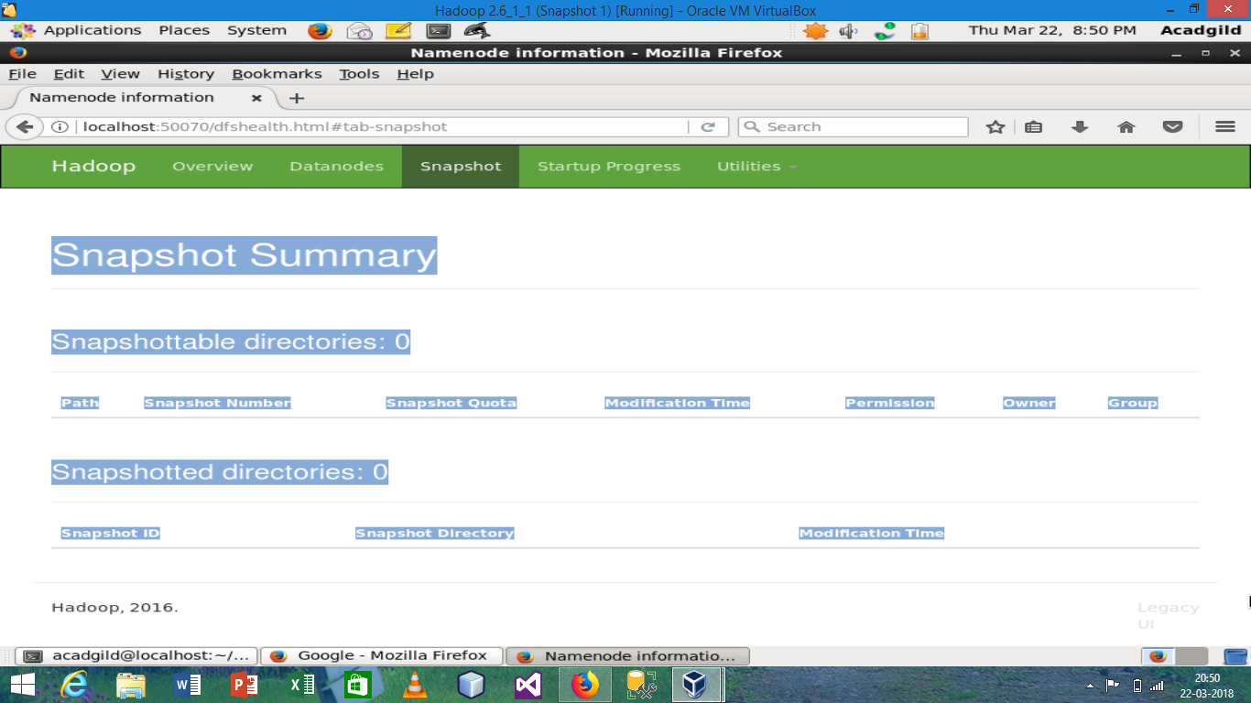

Information about the startup progress

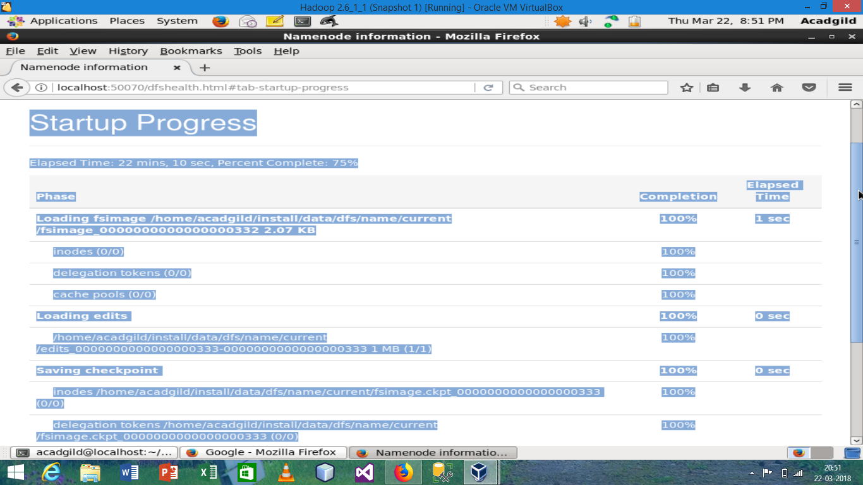

Information about directory logs.

